


DRAFT
May 10th, 2011
Overview: This workbook is intended to serve as a tool for the TPEP district to use as they put together their final evaluation models for teachers and principals. We will use this template as a discussion tool for our May 16-20th TPEP site visits. We constructed this workbook based on the work across the TPEP districts during the 2010-11 “development year.” In the next two months we hope to conclude the work of the “draft” evaluation models and begin to plan for our pilot year. Please note: WE CONSIDER EVERYTHING IN DRAFT FORM UNTIL THERE IS A DECISION BY EITHER THE STEERING COMMITTEE OR SUPERINTENDENT DORN REGARDING THE NEW EVALUATION MODELS.
Where this template asks you to attach documents, please clearly label and email your documents to us (in PDF form if possible). We will insert your documents into the appropriate place per your labeling and guidance. Any explanation of the process or forms you attach should be typed into the appropriate comment box.
Contents
Glossary 2
The What: 2
The How: 3
TPEP Teacher Model Template Diagram 5
Revised Teacher Evaluation Criteria 5
Criteria Definitions 5
Comprehensive Instructional Frameworks 7
Measures & Evidence 9
Final Summative Evaluations 10
System for Determining Final Summative Teacher Rating 10
The How 13
Community & Stakeholder Engagement 13
Communication 13
Professional Development 14
Data 14
Tools & Forms 14

1

Glossary

The What:
Revised Teacher Evaluation Criteria: (Defined in RCW)
The Legislature passed E2SSB 6696 and Governor Gregoire signed the bill into law (RCW 28A.405.100) on March 29, 2010. The criteria form the backbone of the new evaluation system. The TPEP districts have used the evaluation criteria language and existing or new instructional frameworks to develop the rubrics. According to the RCW, “the four-level rating system used to evaluate the certificated classroom teacher must describe performance along a continuum that indicates the extent to which the criteria have been met or exceeded.”

Criteria Definitions: (Defined in WAC and not determined until the conclusion of TPEP Pilot)
Based on feedback from experts and our TPEP districts, we have created definitions for each of the new teacher criterion. Each of the TPEP districts submitted definitions and we synthesized those into one brief sentence. This is intended to delineate the criteria in order to minimize the overlap between the criterion and create more consistency across the state in setting clear evaluation targets for teachers and principals as we move to statewide implementation.

Comprehensive Instructional Framework: (Defined in draft by TPEP Pilots)
The comprehensive instructional framework (common language/model of instruction) provides districts with a way to talk about instruction that is shared by everyone in the district/ESD. Marzano states that teachers and principals use the instructional framework “to converse about effective teaching, give and receive feedback, collect and act upon data to monitor growth regarding the reasoned use of the strategies, and align professional development needs against the framework.” There are several instructional frameworks being utilized by the TPEP districts. Because the new teacher criteria are unique to Washington, the TPEP districts have aligned the instructional frameworks (and subsequently the rubrics) to the new state criteria.

Rubrics: (Defined in draft by TPEP Pilots)
The rubrics (based on the instructional frameworks) are the clearly defined continuum that describes unsatisfactory through effective teaching practice based on the 8 teacher criteria. The rubrics should be used to train principals to identify strengths and weaknesses in practice based on clearly defined evidence and measures. These rubrics could take into account the variations of novice to expert teachers.

Measures and Evidence: (Defined in draft by TPEP Pilots)
The measures and evidence are used to determine the “teacher’s performance along a continuum that indicates the extent to which the criteria have been met or exceeded.” The measures used in the evaluation system should have strong correlation to the criteria being evaluated. There are four areas under the “measures and evidence” section: classroom observation, teacher self-assessment, student growth data, other measures/evidence. This section should represent the district’s system for determining final summative evaluation score.

Final Summative Evaluation: (Defined in WAC and not determined until the conclusion of TPEP Pilot)
The final summative evaluation is a critical definition in order to ensure consistency across the state as teachers are evaluated and data is submitted in aggregate. In the late fall 8 of the 9 TPEP sites and WASA submitted a summative evaluation statement for each of the 4 tiers. Similar to the standards-based system for students, clear targets for both the distinct criteria and the final summative evaluation will drive principals and teachers to a evaluation system that promotes growth and prevents stagnation.
2

The How:

Stakeholder Engagement:
The TPEP project has been a collaborative process from the beginning. Successful development and ultimately implementation has and will require looking at this process through multiple lenses. Please include any documents your district/consortium has used to incorporate authentic stakeholder engagement through the pilot development year. (This will include the norms and protocols you used in setting up your district’s TPEP steering committee)

Communication:
Communication is a key component to successful development and implementation of the new evaluation system. The collaborative approach at both the state and district levels is critical. Include the plan and documents that would explain your communication process.

Professional Development:
Looking at this new evaluation system as a process in continuous improvement, professional development to train the staff involved in the pilot will be key. Please include your district’s plan for ongoing professional development for your teachers, principals and district administrators involved in the 2011-12 TPEP pilot year.

Data:
Many aspects of the new teacher and principal evaluation system will depend heavily on the acquisition and use of data. Include a description of resources your district already uses relating to instructional data and any additional resources you will need to implement the new evaluation system. (Include any technology, databases related to teacher, student, and/or principal data)

Forms & Tools:
Many parts of the new evaluation system will require changing the forms and tools used in the evaluation process. Please include and forms and tools developed for the new evaluation process. (Please note which ones are electronic and which are paper-based). Examples: Principal observation tools (pre, during and post), MOUs, artifact collection and observation tools, parent or student surveys, etc.)
3

TPEP Teacher Model Template Diagram
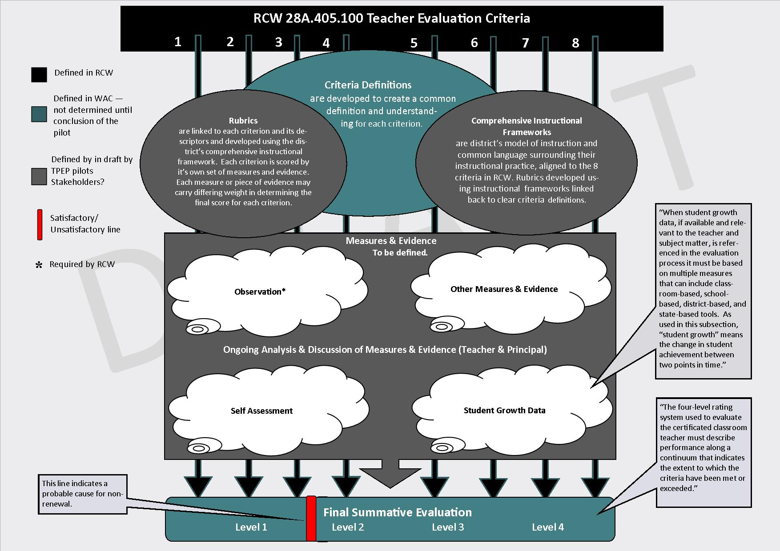
4
Revised Teacher Evaluation Criteria | Criteria Definitions
1. Centering instruction on high expectations for student achievement (i) | PLANNING: The teacher sets high expectations through instructional planning and reflection aligned to content knowledge and standards. Instructional planning is demonstrated in the classroom through student engagement that leads to an impact on student learning.
2. Demonstrating effective teaching practices (ii) | INSTRUCTION: The teacher uses research-based instructional practices to meet the needs of ALL students and bases those practices on a commitment to high standards and meeting the developmental needs of students.
3. Recognizing individual student learning needs and developing strategies to address those needs (iii) | REFLECTION: The teacher acquires and uses specific knowledge about students’ individual intellectual and social development and uses that knowledge to advance student learning.
4. Providing clear and intentional focus on subject matter content and curriculum (iv) | CONTENT KNOWLEDGE: The teacher uses content area knowledge and pedagogy to design and deliver curricula, instruction and assessment to impact student learning.
5. Fostering and managing a safe, positive learning environment (v) | CLASSROOM MANAGEMENT: The teacher fosters and manages a safe, culturally sensitive and inclusive learning environment that takes into account: physical, emotional and intellectual well-being.
6. Using multiple student data elements to modify instruction and improve student learning (vi) | ASSESSMENT: The teacher uses multiple data elements (both formative and summative) for planning, instruction and assessment to foster student achievement.
7. Communicating and collaborating with parents and school community (vii) | PARENTS AND COMMUNITY: The teacher communicates and collaborates with students, parents and all educational stakeholders in an ethical and professional manner to promote student learning.
8. Exhibiting collaborative and collegial practices focused on improving | PROFESSIONAL PRACTICE: The teacher participates collaboratively in the ed

Comprehensive Instructional Frameworks

Select all that apply:
☐ Danielson
☐ Marzano
☐ 5-D (Center for Educational Leadership)
☐ McRel
☐ Other (Teaching as Leadership, National Board, Star Protocol, BERC, etc)
.
Please provide the explanation of how and why your district arrived at your chosen instructional framework, whether it’s a standalone or custom combination:

Rubrics
Please attach rubrics (send as PDFs)
Please provide any explanation or context needed for the rubrics.

Measures & Evidence
Please provide explanations of what your district has developed for:

Student Growth Data
Self-Assessment

Observation

Other Measures & Evidence

Final Summative Evaluation Systems
Final Summative Evaluation
Level 1Level 2Level 3Level 4

System for Determining Final Summative Teacher Rating
☐ Proficiency Progression Model: This model requires choosing one or more criteria that are most critical for the proficiency the first year of implementation/teaching. Subsequent years would stair step proficiency requirements by adding criteria. This model can be combined with other models.
☐ Qualitative/Holistic Model: This model requires collection of artifacts and observation by the evaluator and holistically deriving a qualitative rating on the 4 tiers for each teacher.
☐ Mathematical Formula Model: This model uses a mathematical algorithm to add up each component and divide by the number of indicators/components to drive out a number for each criterion. The same process is completed for the criteria to finalize a summative rating.
☐ Percentage and/or Points Model: This model assigns percentages or points to each form of evidence (Example: Observations are worth 65%, Artifacts 15%, Impacts on Student Learning 15% and self reflection/reflection 5%)
☐ Raw Score Model: This model uses appropriate evidence (observation, artifacts, impact on student learning, self-assessment) to derive a raw score for each criterion. Those criterion scores are then added up to create a summative raw score. Summative rating is defined through a Raw Score Range (Example: Level 1: 8-13 Level 2: 14-19 Level 3: 20-26 Level 4: 27-32)
☐ Raw Score/Conditions Hybrid Model: This model combines the above raw score model with certain district level conditions (example: cannot be overall proficient with one unsatisfactory criterion score or unsatisfactory in safety criterion automatic overall unsatisfactory)
☐ Conditions Model: This model puts certain evaluation conditions depending on the contract status of the teacher.
☐ Other: Many of the above models can be combined or altered to fit the needs of your district evaluation model.
Please provide any explanation or context needed for the model(s) used:

Summative Performance Level Evaluation Statements
These Summative Performance Level Evaluation Statements support teacher self-reflection, inform and structure professional conversations, and suggest areas for further professional growth.
1 | Professional practice at Level 1 shows evidence of not understanding the concepts underlying individual components of the criteria. This level of practice is ineffective and inefficient and may represent practice that is harmful to student learning progress, professional learning environment, or individual teaching practice. This level requires immediate intervention.
2 | Professional practice at Level 2 shows a developing understanding of the knowledge and skills of the criteria required to practice, but performance is inconsistent over a period of time due to lack of experience, expertise, and/or commitment. This level may be considered minimally competent for teachers early in their careers but insufficient for more experienced teachers. This level requires specific support.
3 | Professional practice at Level 3 shows evidence of thorough knowledge of all aspects of the profession. This is successful, accomplished, professional, and effective practice. Teachers at this level thoroughly know academic content, curriculum design/development, their students, and a wide range of professional resources. Teaching at this level utilizes a broad repertoire of strategies and activities to support student learning. At this level, teaching is strengthened and expanded through purposeful, collaborative sharing and learning with colleagues as well as ongoing self-reflection and professional improvement.
4 | Professional practice at the Level 4 is that of a master professional whose practices operate at a qualitatively different level from those of other professional peers. Teaching practice at this level shows evidence of learning that is student directed, where students assume responsibility for their learning by making substantial contributions throughout the instructional process. Ongoing, reflective teaching is demonstrated through the highest level of expertise and commitment to all students’ learning, challenging professional growth, and collaborative leadership.
Adapted from “Framework for Teaching Levels of Performance Sample Operational Definitions” created by Pam Rosa, Danielson Group Associate

The How

Please attach or link to any forms, documents, or protocols you have in the following areas (see glossary for explanation). The comment boxes are for you to add your narrative about the process or documents you’ve attached.

Community & Stakeholder Engagement
Please provide any explanation or context needed for your district’s stakeholder engagement plan.

Communication
Please provide any explanation or context needed for your district’s communications plan.

Professional Development
Please provide any explanation or context needed for your district’s professional development plan.

Data
Please provide any explanation or context needed for your district’s use of data.

Tools & Forms
Please provide any explanation or context needed for your district’s tools and forms.

